E-Commerce Mobile Web Application Proposal
Relic – Mobile E-Commerce Web Application for Handicrafts and Heritage Art Products

1. Introduction
The rapid development of mobile devices and internet technologies has significantly changed the way consumers interact with businesses. Today, customers prefer shopping through mobile web applications because they provide convenience, speed, and accessibility. Traditional physical stores are limited by location and operating hours, whereas mobile e-commerce platforms allow customers to browse and purchase products anytime and anywhere. As a result, businesses are increasingly adopting mobile-based solutions to expand their customer reach and improve service quality.
Relic is a handicraft and antique business that celebrates the rich heritage of fine art and craftsmanship. The store specializes in authentic handmade products, traditional artifacts, and culturally significant items that reflect local artistry and history. However, relying solely on physical sales limits customer accessibility and business growth. Therefore, there is a need to develop a mobile-friendly e-commerce system that enables customers to explore and purchase these products online.
This project proposes the design and development of Relic, a mobile-optimized e-commerce web application that enables users to browse products, add items to a shopping cart, place orders, and submit feedback through an interactive web platform. The system will be developed using ASP.NET Web Forms, HTML5, Tailwind CSS, JavaScript, and Microsoft SQL Server to ensure dynamic functionality, responsive design, and reliable data management.
The proposed application will incorporate appropriate multimedia elements, such as product images and interactive user interfaces, to enhance the overall user experience. In addition, the system will implement secure authentication, well-structured navigation, and efficient administrative management. This project aims to demonstrate both technical competence and the practical application of mobile web multimedia concepts.

2. Target Users
The Relic mobile e-commerce web application is designed to support different types of users, each with specific roles and responsibilities within the system.
- General Customers: These are visitors who access the website without logging in. For example, a user browsing Relic on their mobile phone can view product categories, explore handicraft items, and read product descriptions and images before deciding to register or make a purchase.
- Registered Members: These users create an account on the platform to access member-only features. For example, a registered customer can log in, add products to the shopping cart, place an order, track delivery status, view purchase history, and submit ratings or feedback for purchased products.
- Administrators: Administrators are authorized users responsible for managing the system. For example, an admin can log in to the admin dashboard to add new products, update product details, manage categories, view registered users, and update order statuses such as pending, delivered, or cancelled.

3. Project Aim
The aim of this project is to design and develop a mobile-friendly e-commerce web application that demonstrates effective use of .NET technologies, multimedia elements, and database-driven functionality while fulfilling the learning outcomes of the Mobile Web & Multimedia module.

4. Project Objectives
The general objective of this project is to design and develop a fully functional mobile e-commerce web application that supports online buying and selling of handicraft products while applying appropriate mobile web technologies and multimedia elements.
- Design and develop a responsive, mobile-optimized e-commerce web application compatible with multiple devices and browsers.
- Implement dynamic and interactive web pages using ASP.NET Web Forms and C#.
- Design and integrate a Microsoft SQL Server database to support CRUD operations for users, products, categories, orders, and feedback.
- Enable secure user registration, login, and profile management using ASP.NET Forms Authentication with proper authorization.
- Develop an administrator panel for managing users, products, categories, and orders with full CRUD capabilities.
- Implement a shopping cart system allowing users to add, update, and remove items, along with order placement and tracking functionalities.
- Allow customers to submit ratings and feedback while ensuring form validation, secure navigation, and data integrity across the system.

5. Problem Statement
Despite the increasing digitalization of retail, many small businesses, particularly those dealing with handicrafts and heritage art, still rely on physical stores or informal social media channels for sales. This approach presents several challenges:
- Limited Customer Reach: Physical stores restrict the audience to local foot traffic, reducing potential sales and limiting market expansion. Social media pages lack structured organization, making it hard for customers to browse products effectively.
- Inefficient Product Management: Without a dedicated platform, tracking inventory, product categories, and updates is time-consuming and prone to errors. Products may go out of stock without proper notifications, impacting customer satisfaction.
- Poor Customer Experience: Customers cannot track orders, access detailed product information, or provide structured feedback, resulting in low engagement and trust.
- Administrative Burden: Manual record-keeping of sales, orders, and customer interactions increases workload, introduces human error, and reduces operational efficiency.
- Limited Scalability: As demand grows, physical and informal sales channels cannot easily accommodate more users, orders, or product listings.
In summary, there is a need for a centralized, mobile-friendly, and database-driven e-commerce platform that provides both customers and administrators with a structured, interactive, and efficient system for buying and selling heritage products.

6. Proposed Solution
The proposed solution is Relic, a mobile-optimized e-commerce web application that addresses these challenges by providing:
- Structured Online Shopping: Users can browse categorized products with detailed images, descriptions, and pricing, creating a smooth and intuitive shopping experience.
- User Account Management: Customers can create accounts, log in securely, and maintain profiles for easy future purchases.
- Shopping Cart & Checkout: Customers can add products to a cart, modify quantities, and place orders efficiently.
- Order Tracking: Users can view order history, track delivery status, and receive updates on order processing.
- Customer Feedback: A feedback and rating system enables users to review products, fostering trust and engagement.
- Admin Dashboard: Administrators can manage products, categories, users, and orders from a secure interface. Advanced features include adding new products, updating stock, and reviewing customer feedback.
- Mobile-First Design: The application will adapt to different screen sizes, ensuring accessibility and usability on smartphones, tablets, and desktops.
- Multimedia Integration: Product images, responsive layouts, and interactive elements enhance user engagement while maintaining performance.
By combining these features, Relic not only improves customer experience but also reduces administrative workload, increases efficiency, and provides scalability for business growth.

7. Technology Stack
The technology stack has been chosen to ensure performance, security, and maintainability:
- Frontend:
- HTML5: Structures the content and ensures semantic web standards.
- Tailwind CSS: Provides a responsive and mobile-first design framework, allowing fast development and uniform styling.
- JavaScript: Enables client-side interactivity, dynamic updates, and form validation.
- Backend:
- ASP.NET Web Forms (C#): Handles server-side processing, dynamic page generation, and integration with databases.
- ASP.NET Forms Authentication: Secures member-only and admin-only pages.
- Database:
- Microsoft SQL Server Express: Stores user, product, order, and feedback data securely. Relationships and constraints ensure data integrity.
- Development Tools & Environment:
- Visual Studio: Integrated development environment for building, debugging, and deploying the web application.
- Windows OS: Provides a stable development and testing environment.
- Web Controls:
- GridView, Repeater, DataList: Display data dynamically for product lists, order histories, and user management dashboards.
This combination ensures a robust, scalable, and maintainable web application capable of supporting mobile e-commerce effectively.

8. Key Features
1. Customer-Facing Features:
- User Registration & Login: Secure accounts with role-based access.
- Mobile-Friendly Product Catalogue: Browse products by categories, with images and detailed descriptions.
- Shopping Cart & Checkout: Add, remove, and modify product quantities; place orders seamlessly.
- Order Tracking: Track order status from placement to delivery.
- Feedback & Ratings: Rate products and provide textual feedback.
2. Admin-Facing Features:
- Dashboard Management: Add, update, or delete products and categories.
- User Management: Monitor and manage customer accounts.
- Order Management: View, update, and process orders efficiently.
- Report Generation: Generate sales reports and product popularity insights.
3. Other Features:
- Form validation to prevent errors during data entry.
- Responsive navigation menus and multimedia elements for enhanced usability.

9. Project Scope
Included in Scope:
- Development of user authentication and profile management.
- Full product catalogue with categories, images, and descriptions.
- Shopping cart, checkout, and order management system.
- Customer feedback and rating functionality.
- Admin dashboard for product, user, and order management.

Excluded from Scope:
- Real-time online payment gateway integration (e.g., credit card or digital wallet payments).
- Integration with third-party delivery services.
Scope Clarification:
The application will focus on providing a complete e-commerce experience through a web platform optimized for mobile devices, while administrative tasks will be fully manageable through a secure backend.

10. System Designs

10.1. Database Design (ERD)
The system uses Microsoft SQL Server to store all application data. The database will be stored in the App_Data directory and connected using the AttachDBFilename option in the web.config file.
Main entities include:
- Customer
- Category
- Product
- Order
- Order_Item
- Cart
- Review
- Payment
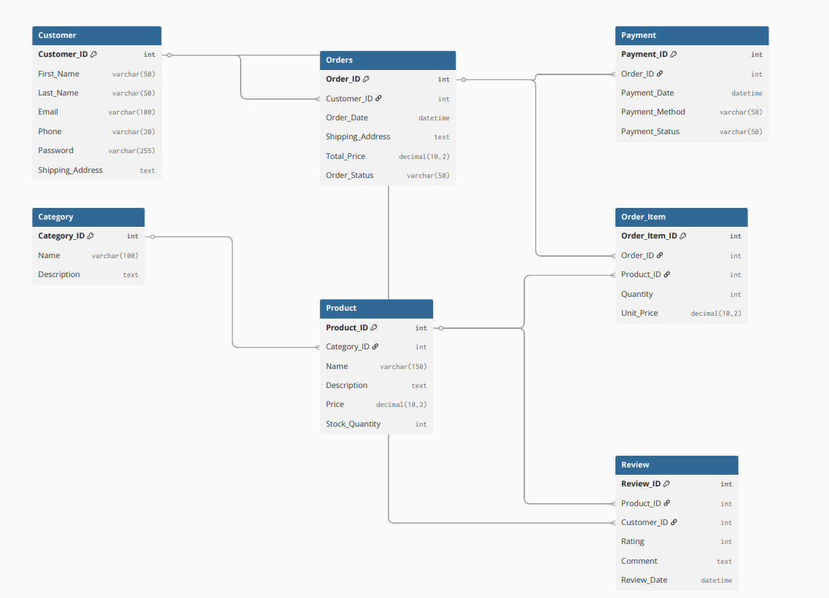
Relationships ensure proper data integrity, such as one user having multiple orders and one category containing multiple products.
SN | Parent Table | Child Table | Relationship Type | Foreign Key | Description
1 | Customer | Order | One-to-Many | Customer_ID | One customer can place multiple orders.
2 | Category | Product | One-to-Many | Category_ID | One category can have multiple products
3 | Order | Order_Item | One-to-Many | Order_ID | One order can contain multiple items
4 | Product | Order_Item | One-to-Many | Product_ID | One product can appear in many order items.
5 | Customer | Review | One-to-Many | Customer_ID | One customer can write multiple reviews.
6 | Product | Review | One-to-Many | Product_ID | One product can receive many reviews
7 | Order | Payment | One-to-One | Order_ID | Pairs one order with one payment receipt.

10.2. Use Case Diagram
The system has two primary actors: Customer and Administrator.
Customers interact with the system to browse products, purchase items, and provide feedback. Administrators interact with the system to manage users, products, and orders.
The Use Case Diagram illustrates these interactions and helps visualize the functional scope of the application.
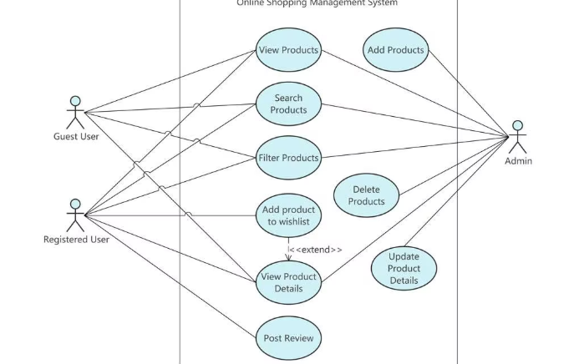

10.3. Activity Diagram
The activity diagram demonstrates the flow of the purchasing process:
Start → Login/Register → Browse Products → Add to Cart → Review Cart → Checkout → Confirm Order End
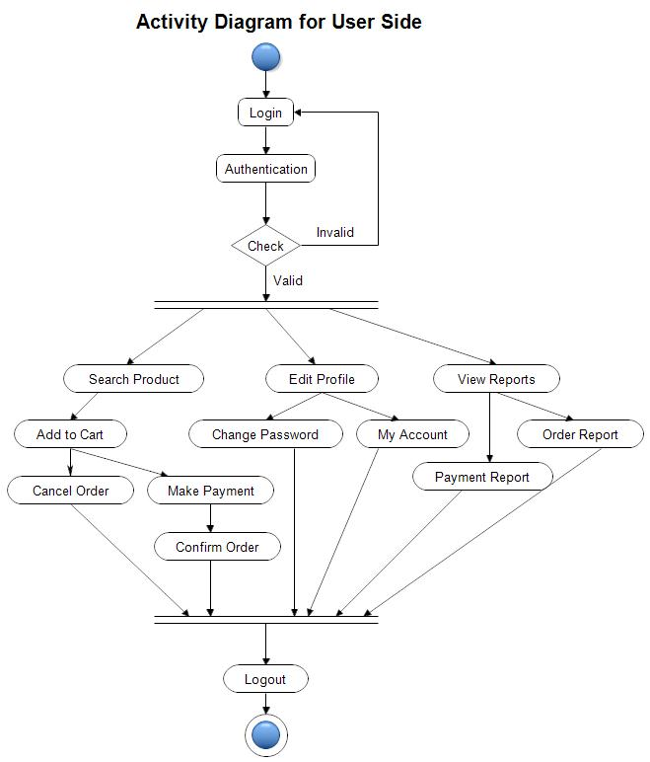
This diagram helps understand the sequence of steps involved in completing a purchase.

10.4. Wireframe
Mobile-first page layouts for home, product catalog, product detail, cart, checkout, and admin dashboard.
Login page
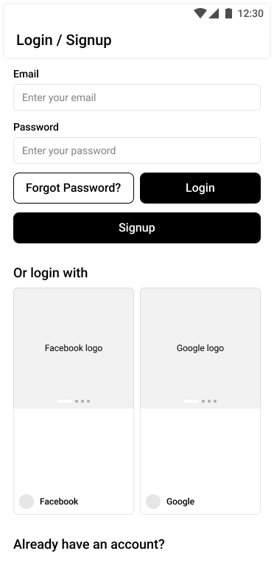
User account
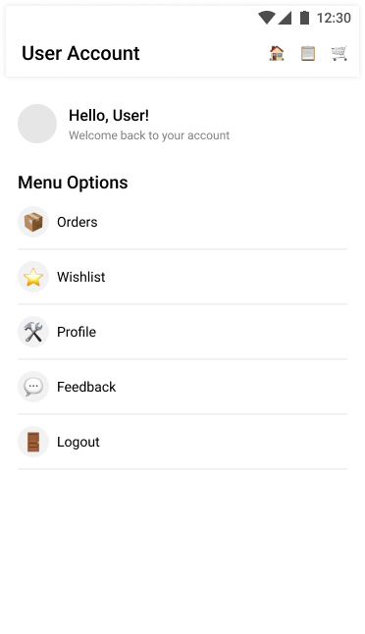

Home page wireframe
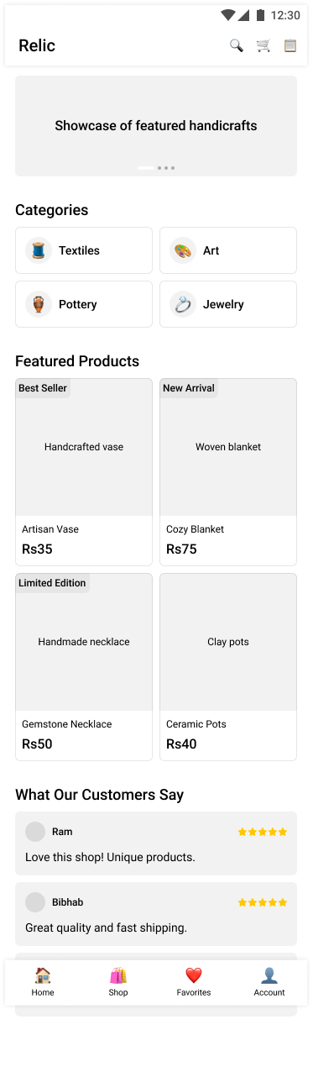
Shop page
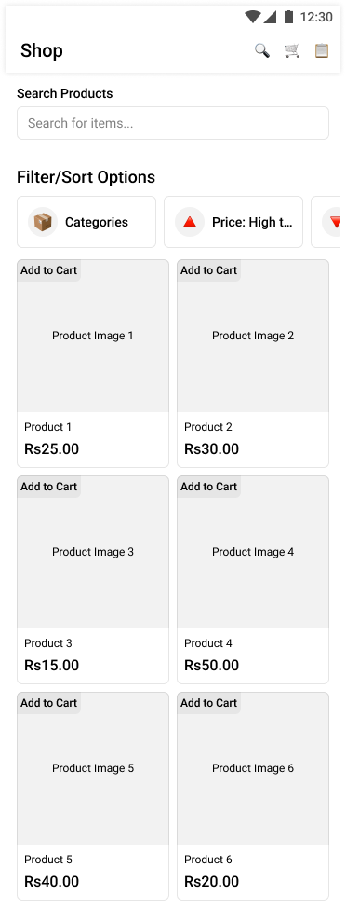
Product details page
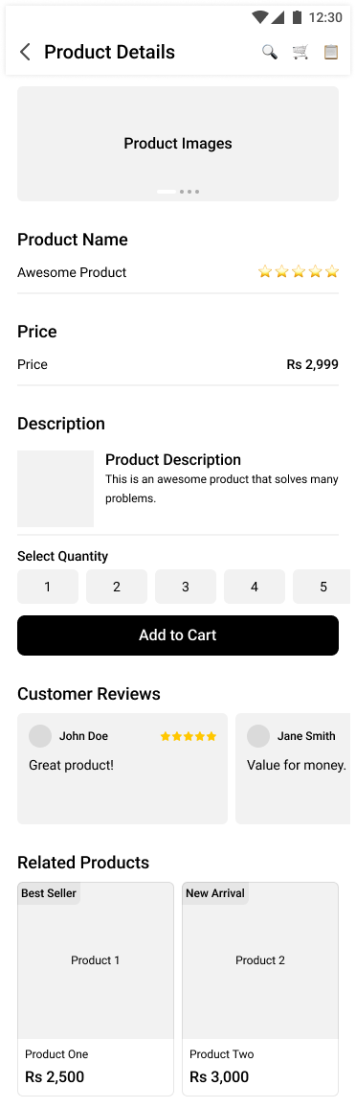

Shopping cart
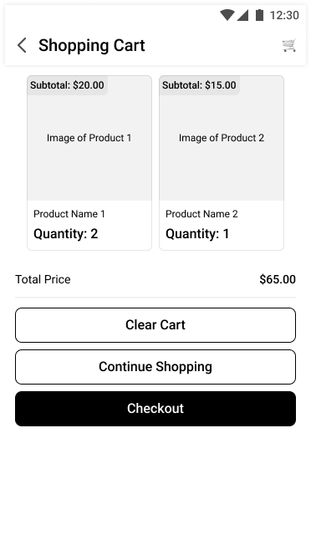

Checkout
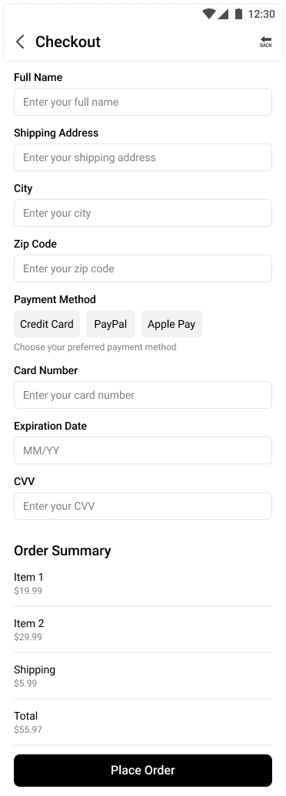
Admin dashboard
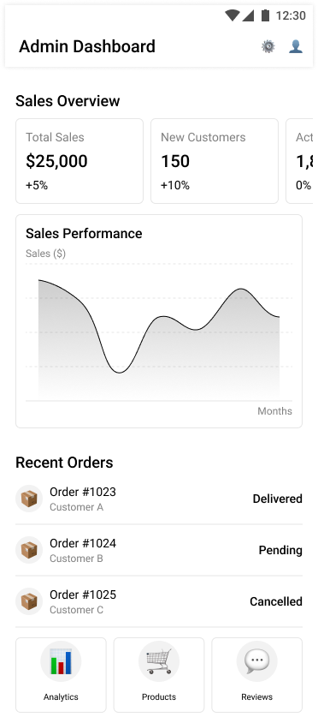

11. Conclusion
In conclusion, the Relic mobile e-commerce web application aims to provide a modern, efficient, and user-friendly platform for purchasing handicrafts and heritage art products online. The system will combine responsive design, dynamic web technologies, and database integration to deliver a seamless shopping experience.
By implementing ASP.NET Web Forms, Tailwind CSS, and SQL Server, the application will demonstrate proper web development practices, secure authentication, and structured system architecture. The proposed system not only fulfills the academic requirements of the assignment but also reflects real-world business solutions that enhance customer accessibility and operational efficiency.
The successful completion of this project will showcase strong technical knowledge, design skills, and the ability to construct a fully functional mobile web multimedia application.

